Pyber Rideshare Analysis

# Overview of Analysis

The purpose of this analysis is to understand any overall patterns and themes with ridesharing in urban, suburban, and rural communities. The data findings are meant to assist decision makers in growth strategy to meet demand at the right time. This project also helped me to learn more about importing and merging Pandas DataFrames. I was able to determine mean, median and mode for number of rides, fares and drivers per city type.

# Results

* Urban communities generate more than double the number of rides than suburban communities.

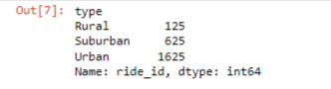

* Rural communities generate only 8% of the number of rides as the urban communities.
* Urban city types have much more drivers than total rides requested while rural & suburban city types had more ride demand than drivers available.

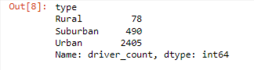

* While urban communities led in the total amount of fares earned, rural and suburban communities average ride fare was higher.

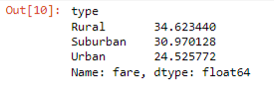

* The average far per driver for rural and suburban drivers was more than double that of urban city drivers.

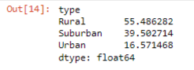

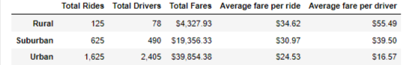

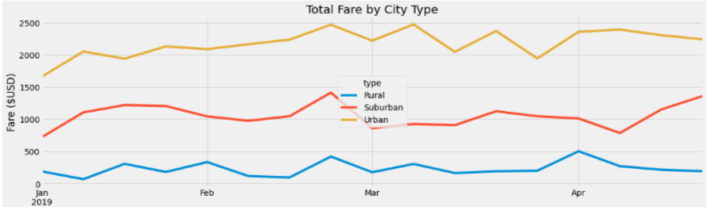

# Summary

Based on these results, I would recommend the following to the CEO to address the disparities:

* Encourage urban city type drivers to help meet the demand in rural and suburban communities.
* Provide incentives or advertising for riders in urban communities to encourage more rideshare requests in urban communities to help meet the oversupply of drivers.
* Conduct campaign to encourage overall ridesharing as a viable option for transportation while incentivizing drivers to refer new drivers to help meet demand.
* Conduct another analysis, looking at days of the week and time impacts.